UML Assignment

Class Diagram

1. Airline Reservation System

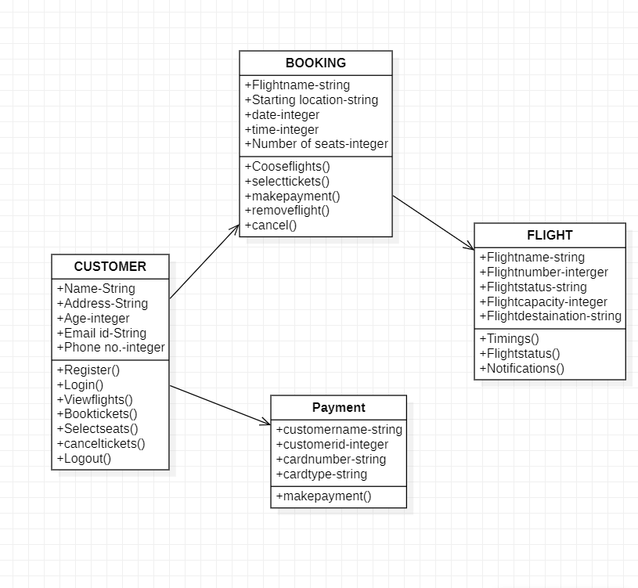

1. Class Diagram for University

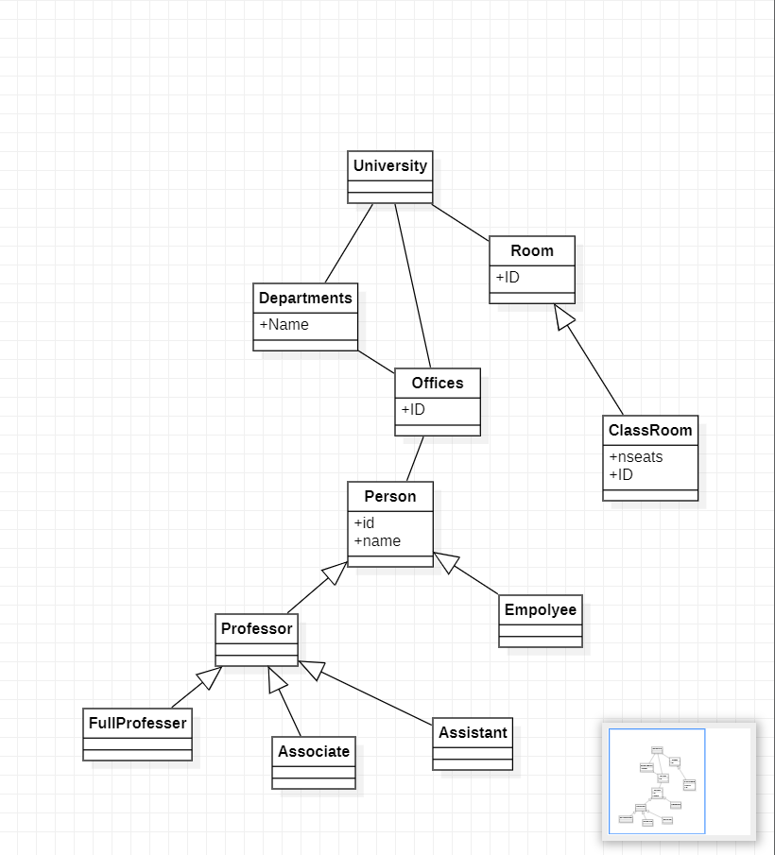

1. Activity Diagram for Student Enrolment in the university.

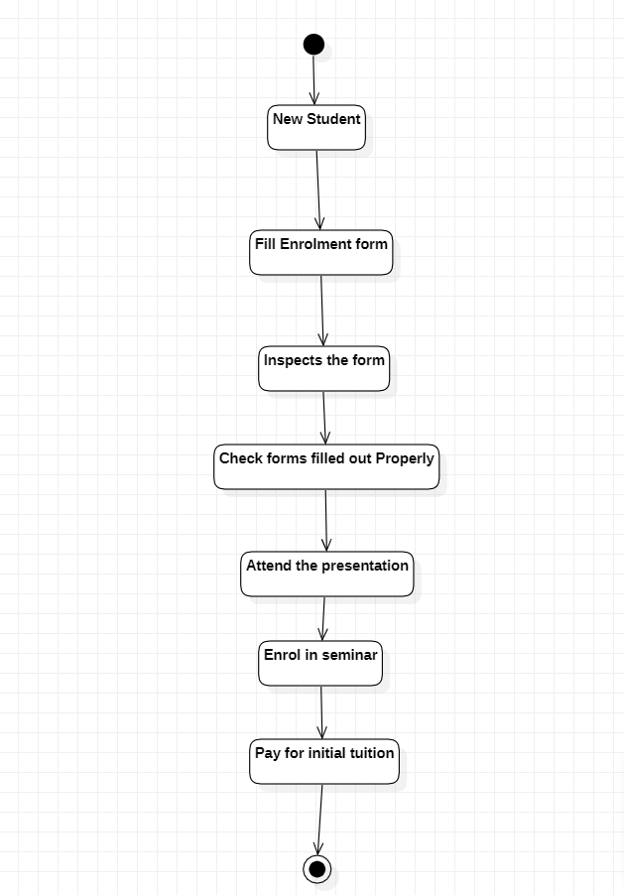

4. Sequence Diagram for Online Library Management System.

